Assignment .1

1. Layout Widgets
Widgets used to arrange, align, pad, or constrain other widgets.

Container
- Description: A versatile utility widget that combines common painting, positioning, and sizing widgets. It's commonly used to add margins, padding, background colours, borders, and fixed dimensions to child widgets.
- Visual Demonstration:
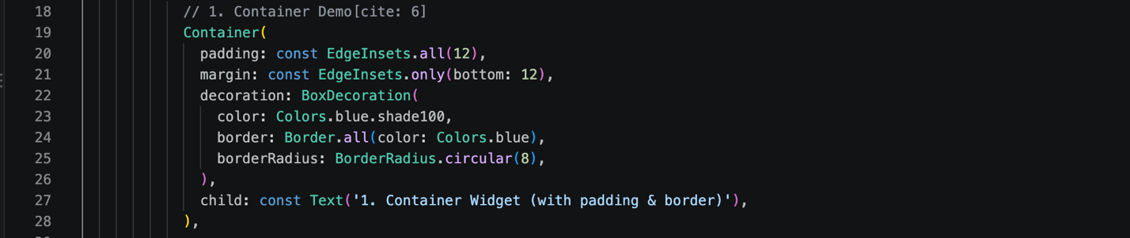

Row & Column
- Description: Flex-based layout widgets used to place child widgets linearly. Row arranges children horizontally along the main axis, while Column arranges them vertically.
- Visual Demonstration:

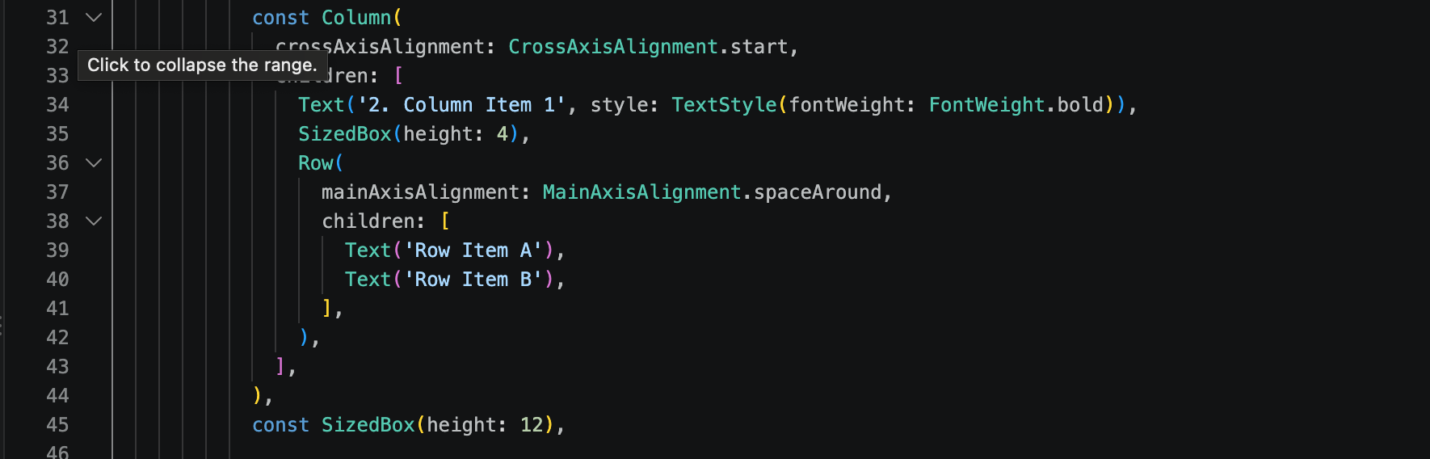

Stack
- Description: A widget that allows children to overlap one another relative to the edges of its box. This is extremely useful for layering UI elements, such as placing text over an image.
- Visual Demonstration:

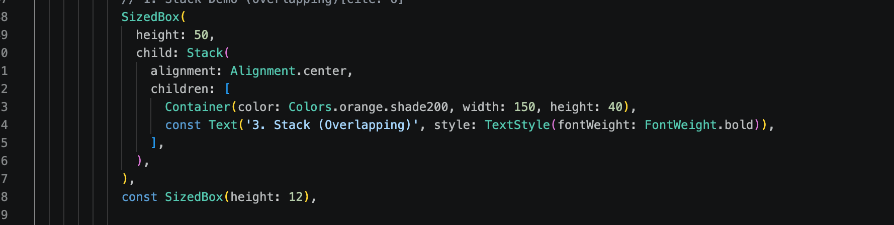

2. Structural & Navigation Widgets
Widgets that provide the core visual framework and navigation layout of an app.

Scaffold
- Description: Implements the basic Material Design visual layout structure. It provides standard support and APIs for visual elements like AppBars, Bottom Navigation Bars, Drawers, SnackBar, and Floating Action Buttons.
- Visual Demonstration:
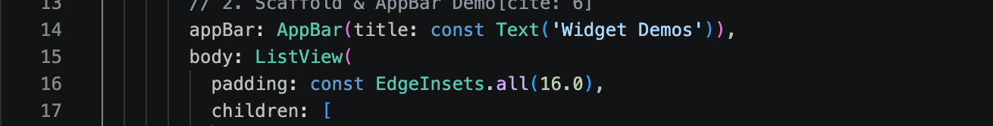

AppBar
- Description: A Material Design app bar typically placed at the top of the screen (Scaffold.appBar). It holds the screen title, action buttons, leading navigation icons, and tabs.

3. Content & Display Widgets
Widgets focused on presenting static or dynamic content like text, media, and scrollable lists.

Text
- Description: A foundational widget used to display a string of text with single or multiple styles, fonts, weights, and colours.

Image
- Description: Displays image assets from various sources, including local asset bundles, network URLs, files, or memory bytes.

ListView
- Description: A scrollable, linear list of widgets. It is ideal for displaying long lists of repeating items or mixed content types efficiently.

4. Input & Interactive Widgets
Widgets that capture user interaction, taps, gestures, or data entry.

ElevatedButton
- Description: A raised, Material Design button that casts a shadow and elevates upon being pressed, signalling a primary action to the user.
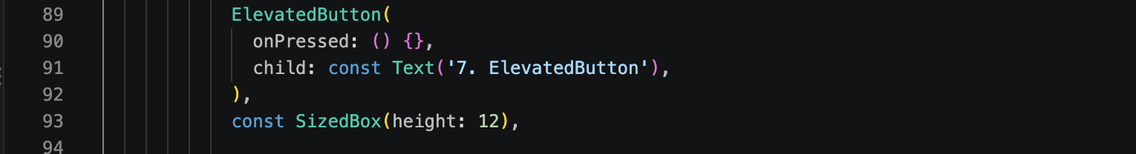

TextField
- Description: A text input component that allows users to type, edit, and submit text input, commonly utilised in login forms, search bars, and user profiles.
